International Conference on Structural Engineering Research (iCSER-2019)
19-23 January 2019, Dhaka, Bangladesh

Organised by:
Global Circle for Scientific, Technological and Management Research, Australia (http://www.gcstmr.com.au/)
and
Department of Civil Engineering, BUET, Dhaka, Bangladesh
(http://ce.buet.ac.bd/)

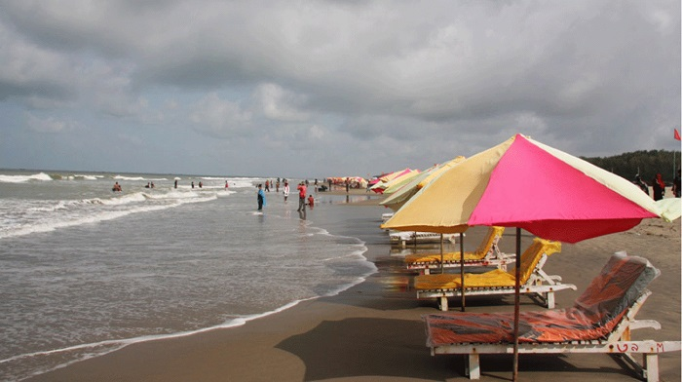

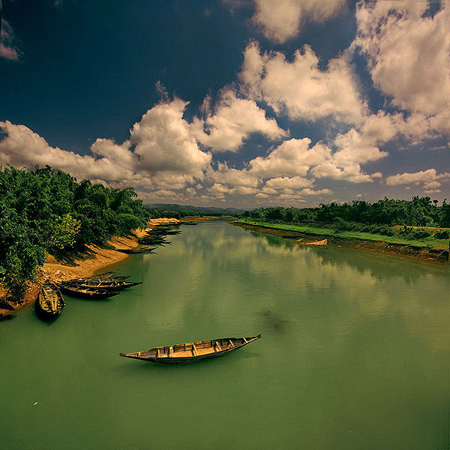

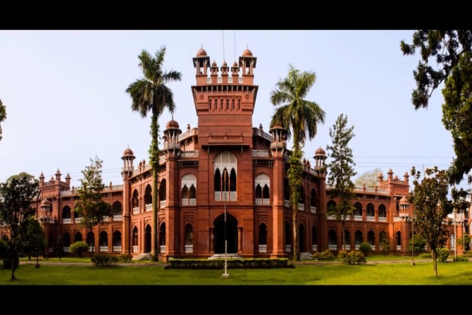

CONFERENCE INFORMATION

The International Conference on Structural Engineering and Research (iCSER-2019, Dhaka) will bring international and national experts in Structural Engineering to Dhaka (the capital city of Bangladesh) to present and share their latest research and practice.

Infrastructure is a key aspect of modern civilisation. Structural engineers plan, design and construct numerous structures such as buildings, roads, tunnels and bridges among other infrastructure. The recent research, practice and advancements in Structural Engineering will be discussed by many international leading experts and professionals who will gather at iCSER-2019, Dhaka, Bangladesh. The main objectives of this conference are to provide an opportunity for professional interaction amongst the researchers, engineers, academics and students, and to showcase the latest developments and future trends in their fields.

The iCSER-2019 is supported by the Global Circle for Scientific, Technological and Management Research (GCSTMR) as its 4th World Congress. GCSTMR endeavours to create a platform for young researchers to exchange ideas and share information with experts in their respective fields. GCSTMR encourages and facilitates trans-national collaborations among its members and associates in research, training and professional activities. Multidisciplinary international conference series run by GCSTMR could open vast opportunities for researchers enabling them to interact on the global platform, as well as to seize the advantage of knowledge sharing in the digital arena

The 4th GCSTMR Congress is jointly organized by GCSTMR, Bangladesh University of Engineering and Technology (BUET), Bangladesh Open University (BOU), Daffodil International University (DIU), Islamic University of Technology (IUT), Dhaka University of Engineering and Technology (DUET) and the Business Faculty of the Dhaka University (DU). The conference venue is 20 km away from the airport and many international standard hotels, motels, guest houses and resorts are situated in and around the venue.

Bangladesh, an emerging economic power in Asia, is also popular for its two main tourist attractions: Cox’s Bazar, a contender for the title of longest unbroken sandy sea beach in the world and the Sundarbans, the largest mangrove forest of the world with the Royal Bengal Tiger and the Spotted Deer. For more information, visit http://www.tourismboard.gov.bd/.

The iCSER-2019 will feature keynote addresses by world leaders in Structural Engineering. All the abstracts and full papers submitted to iCSER-2019will be assessed by an independent review panel and if accepted will be published in the Conference Proceedings with Australian ISBN Number.
CONFERENCE THEMES

- Advanced sensor networks, structural monitoring and control
- Advanced structural experimental techniques
- Building structures, bridge structures and underground structures
- Construction monitoring and control for large-scale structures
- Disaster-prevention and hazard mitigation for infrastructure
- Earthquake engineering
- Large scale and complex infrastructure and spatial structures
- Novel hybrid structural systems and composites for structures
- Numerical analysis of structures using finite element modelling
- Performance-based design
- Prefabricated building and bridge structures
- Reliability and durability of structures
- Structural fire engineering
- Structural identification and damage detection
- Structural rehabilitation, retrofitting and strengthening
- Structural wind engineering
- Theories and methods of structural analysis
- Other areas of structural and construction engineering

ORGANISING COMMITTEE

Chair: Assoc. Prof. Dr. Ataur Rahman, Western Sydney University, Australia
Co-Chair: Prof. Dr. Shibli R U Islam, Dhaka University, Bangladesh
Co-Chair: Prof. Dr. Chin Leo, Western Sydney University, Australia
Co-Chair: Prof. Dr. Ahsanul Kabir, Bangladesh University of Engineering and Technology (BUET), Bangladesh
General Secretary: Dr. Amir Ahmed, Daffodil International University, Bangladesh
Co-General Secretary: Dr. Hasan Hafizur Rahman, STAMCA, Sydney, Australia
Co-General Secretary: Assoc. Prof. Dr. Amimul Ahsan, Uttara University, Bangladesh
Co-General Secretary: Dr. Md. Kamrul Hassan, Western Sydney University, Australia
Treasurer: Dr. Shafiqul Alam, Registrar, Bangladesh Open University, Bangladesh
Co-Treasurer: Dr. Rezaul Bashar, STAMCA, Sydney, Australia
Marketing: Engr. A F M Ali Ashraf, GCSTMR, Australia
Hospitality: Mr. Iftekhar Khalid, Bangladesh Open University, Bangladesh.

Executive Members:
Prof. Dr. Andre M N Renzaho, Western Sydney University, Australia
Prof. Dr. Shams Rahman, RMIT University, Australia
Assoc. Prof. Dr. Fidelis Mashiri, Western Sydney University, Australia
Prof. Dr. Raquib Ahsan, BUET, Bangladesh
Prof. Dr. Mahbuba Begum,BUET, Bangladesh
Dr. Rafiqul Islam, Solar E. Technology, Australia
Prof. Dr. Rezaul Karim, Islamic University of Technology, Bangladesh
Dr. M. Rafiqul Islam, Charles Sturt University, Australia

ADVISORY COMMITTEE

Chair: Prof. Dr. M A Mannan, Vice Chancellor, Bangladesh Open University
Co-Chair: Dr. Md. Sabur Khan, Chairman (Board of Trustee), Daffodil International University, Bangladesh
Members:
Prof. Dr. Atiur Rahman, Professor, Dhaka University
Prof. M A Hannan, Rector, Engineering Staff Collage
Prof. Dr. Iftekhar Uddin Chowdhury, Vice Chancellor, Chittagong University, Bangladesh
Prof. Dr. Mohammad Rafiqul Alam, Vice Chancellor, Chittagong University of Engineering and Technology, Bangladesh
Prof. Dr. Md. Alauddin, Vice Chancellor, Dhaka University of Engineering and Technology, Bangladesh
Prof. Dr. Omar Jah, Pro Vice Chancellor, Islamic University of Technology, Bangladesh
Prof. Dr. Yusuf Mahbubul Islam, Vice Chancellor, Daffodil International University, Bangladesh
Prof. Dr. S. M. Imamul Huq, Vice Chancellor, University of Barisal, Bangladesh
Prof. Dr. Jahirul Haque, Vice Chancellor, University of Liberal Arts, Bangladesh
Prof. Dr. Gias U Ahsan, Pro Vice Chancellor, North South University, Bangladesh
Prof. Dr. Akhtar Kamal, Victoria University, Australia
Prof Dr. Vivian Tam, Western Sydney University, Australia
Prof. Dr. Taha B. M. J. Ouarda, National Institute of Scientific Research, INRS, Canada
Prof. Dr. Biswajeet Pradhan, University of Technology Sydney, Australia
Prof. Dr. Abdallah Shanableh, University of Sharjah, United Arab Emirates
Prof. Dr. Henry Wong Kwai Kwan, ENTPE Universite De Lyon, France
Prof. Dr. Chi Zhang, Dalian University of Technology, China
Mr. Kazi Nasir, Chief Architect, Department of Housing and Public Works, Bangladesh.
Prof. Dr. Abu Bakr Rafique, Former CEO, International Islamic University of Chittagong, Bangladesh
Mr. Mukit Majumdar Babu, Chairman, Prokriti O Jibon Foundation and Sponsor Director, Channel I, Bangladesh
Prof. Dr. Abdur Rashid, Dean, Uttara University, Bangladesh
Prof. Dr. Ahsanul Kabir, , BUET, Bangladesh
Prof. Dr. Sk. Sekender Ali, BUET, Bangladesh
Prof. Dr. Md. Shafiul Bari, BUET, Bangladesh
Prof. Dr. Md. Zakaria Ahmed, BUET, Bangladesh
Prof. Dr. Ishtiaque Ahmed, BUET, Bangladesh
Prof. Dr. Bashir Ahmed, BUET, Bangladesh
Prof. Dr. Khan Mahmud Amanat, BUET, Bangladesh
Prof. Dr. Mehedi Ahmed Ansary, BUET, Bangladesh
Prof. Dr. A.F.M. Saiful Amin, BUET, Bangladesh
Prof. Dr. Harunur Rashid, Khulna University of Engineering and Technology, Bangladesh
Prof. Dr. Monjur Hossain, Former Professor, Khulna University of Engineering and Technology, Bangladesh
Prof. Dr. Md. Tarek Uddin, Islamic University of Technology, Bangladesh
Prof. Dr. Sharmin Reza Chowdhury, Ahsanullah University of Science and Technology, Bangladesh
Prof. Dr. Mohammad Nazmul Islam, North South University, Bangladesh
Prof. Dr. Md. Jahangir Alam, Chittagong University of Engineering and Technology, Bangladesh
Prof. Dr. Md. Saiful Islam, Chittagong University of Engineering and Technology, Bangladesh

TECHNICAL COMMITTEE

Chair: Assoc. Prof. Dr. Fidelis Mashiri, Western Sydney University, Australia
Co-Chair: Assoc. Prof. Dr. Swapan Saha, Western Sydney University, Australia
Co-Chair: Prof. Dr. Raquib Ahsan, Bangladesh University of Engineering and Technology, Bangladesh

Secretary: Dr. Md Kamrul Hassan, Western Sydney University, Australia
Co-Secretary: Dr. Md. Naimul Haque, East West University, Bangladesh
Co-Secretary: Dr. Nazrul Islam, BUET, Bangladesh

Executive Members:
Prof. Dr. Ahsanul Kabir, BUET, Bangladesh
Prof. Dr. Mehedi Ahmed Ansary, BUET, Bangladesh
Prof. Dr. Tahsin Reza Hossain,BUET, Bangladesh
Prof. Dr. Syed Ishtiaq Ahmad, BUET, Bangladesh
Prof. Dr. Mahbuba Begum, BUET, Bangladesh
Prof. Dr. Tanvir Manzur, BUET, Bangladesh
Prof. Dr. Md. RabiulAlam, East West University, Bangladesh
Prof. Dr. Md. Moinul Islam, Chittagong University of Engineering and Technology, Bangladesh
Prof. Dr. G M Sadiqul Islam, Chittagong University of Engineering and Technology, Bangladesh
Prof. Dr. Md. Nazrul Islam, Dhaka University of Engineering and Technology, Bangladesh
Prof. Dr. Ganesh Chandra Saha, Dhaka University of Engineering and Technology, Bangladesh
Prof. Dr.Abdur Rashid, Daffodil International University, Bangladesh
Prof. Dr. Harunur Rashid, Khulna University of Engineering and Technology, Bangladesh
Prof. Dr. Md. Tarek Uddin, Islamic University of Technology, Bangladesh
Prof. Dr. Sharmin Reza Chowdhury, AUST, Bangladesh
Prof. Dr. Mohammad Nazmul Islam, North South University, Bangladesh
Prof. Dr. Morgan Dundu, University of Johannesburg, South Africa
Assoc. Prof. Dr. Mohammad Al Amin Siddique, BUET, Bangladesh
Assoc. Prof. Dr. Ataur Rahman, Khulna University of Engineering and Technology, Bangladesh
Assoc. Prof. Dr. Neaz Sheikh, University of Wollongong, Australia
Assoc. Prof. Dr. Muhammad Hadi, University of Wollongong, Australia
Assoc. Prof. Dr. PrabirSarker, Curtin University, Australia
Assoc. Prof. Mahmud Ashraf, Deakin University, Australia
Asst. Prof. Dr. Shameem Ahmed, BUET, Bangladesh
Asst. Prof. Dr. Md. Raquibul Hossain, BUET, Bangladesh
Asst. Prof. Dr. Shohel Rana, BUET, Bangladesh
Asst. Prof. Dr. Nazrul Islam, BUET, Bangladesh
Asst. Prof. Dr.RupakMutsuddy, BUET, Bangladesh
Dr. Mohamed Ghannam, Mansoura University, Egypt
Dr. Mohammad Masud Rana, University of New South Wales, Australia
Dr. Mohammad Yousuf, Western Sydney University, Australia

KEY DATES

Closing date for abstract submission: 10 Oct 2018
Notification of acceptance/rejection to author: 17 Oct 2018
Full paper or extended abstract submission due: 17 Nov 2018
Full paper review report to author: 30 Nov 2018
Final paper or extended abstract due: 15 Dec 2018
Early bird registration opens: 17 Oct 2018
Early bird registration closes: 31 Dec 2018
Conference date: 19-23 Jan 2019

ABSTRACT AND FULL PAPER SUBMISSION

Please visit the conference websiteto download the template to prepare your abstract or full paper and follow the link to make the submissionviaEasyChair.

OPPORTUNITY TO PUBLISH IN JOURNALS

Selected authors will have the opportunity to publish the iCSER-2019 conference papers in the International Journal of Engineering, Construction and Computing (IJECC) (subject to satisfying the criteria of the journal). IJECC is an Open Access fully refereed international journal published from Australia.

REGISTRATION FEES

Subclass | Early Birds |  | Bird on Time
 | Bangladesh Delegates | International Delegates | Bangladesh Delegates | International Delegates
Full Days Delegates | Tk 4000 | US$ 350 | Tk 4500 | US$ 400
Full Days Students | Tk 2000 | US$ 200 | Tk 2500 | US$ 250
One Day Delegate | Tk 2500 | US$ 250 | Tk 3000 | US$ 275
One Day Student | Tk 1500 | - | Tk 1800 | -
Accompanying Family Member | Tk 1500 | US$ 100 | Tk 2000 | US$ 125
Conference Dinner | Tk 1500 | US$ 50 | Tk 1500 | US$ 50
Charge for the 3rd paper or 4th paper | Tk 1000 | US$ 50 | Tk 1000 | US$ 50
Paper publication in the Proceedings without conference attendance | Tk 2500 | US$ 250 | Tk 2500 | US$ 250
*International delegates and international students from countries with a per capita GDP of less than US$ 10,000 (World Bank, 2014) will receive a 50% discount on the registration fee.

FURTHER INFORMATION

Conference Secretary:
Dr. Md. Kamrul Hassan,
Western Sydney University, Australia
Email: K.Hassan@westernsydney.edu.au
Tel: +61 424 350 257

Chair (Technical Committee):
Assoc. Prof. Dr. Fidelis Mashiri,
Western Sydney University, Australia
Email: F.Mashiri@westernsydney.edu.au
Tel: +61 2 47360355

Chair (Organising Committee):
Assoc. Prof. Dr. Ataur Rahman
Western Sydney University, Australia
Email: a.rahman@westernsydney.edu.au
Tel: +61 430 137 299

General Secretary (Organising Committee):
Dr. Amir Ahmed
Daffodil International University, Bangladesh,
Email: aaff1273@gmail.com
Tel: +880 1777 180 046

Lead Secretary (GCSTMR):
Dr. Hasan Hafizur Rahman
Email: hasanhrahman@hotmail.com
Tel: +61 431 070 618

